ADD NEW Patient to Patients Page (Pre-Add)

ADD NEW Patient to Patients Page (Post-Add)

BROWSE Patients Page

SEARCH Patient in Patients Page (Pre-Search)

SEARCH Patient in Patients Page (Post-Search)

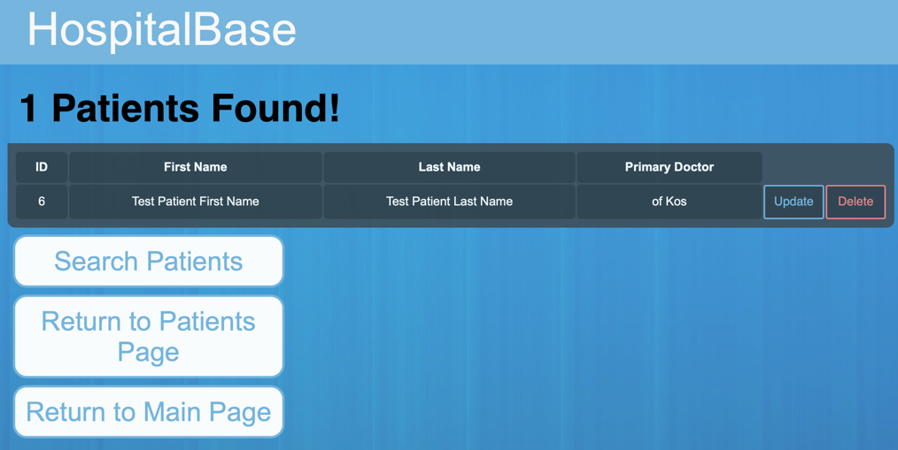

UPDATE Patient in Patients Page (Pre-Update)

UPDATE Patient in Patients Page (During-Update)

UPDATE Patient in Patients Page (Post-Update)

Delete Patient From Patients Page

